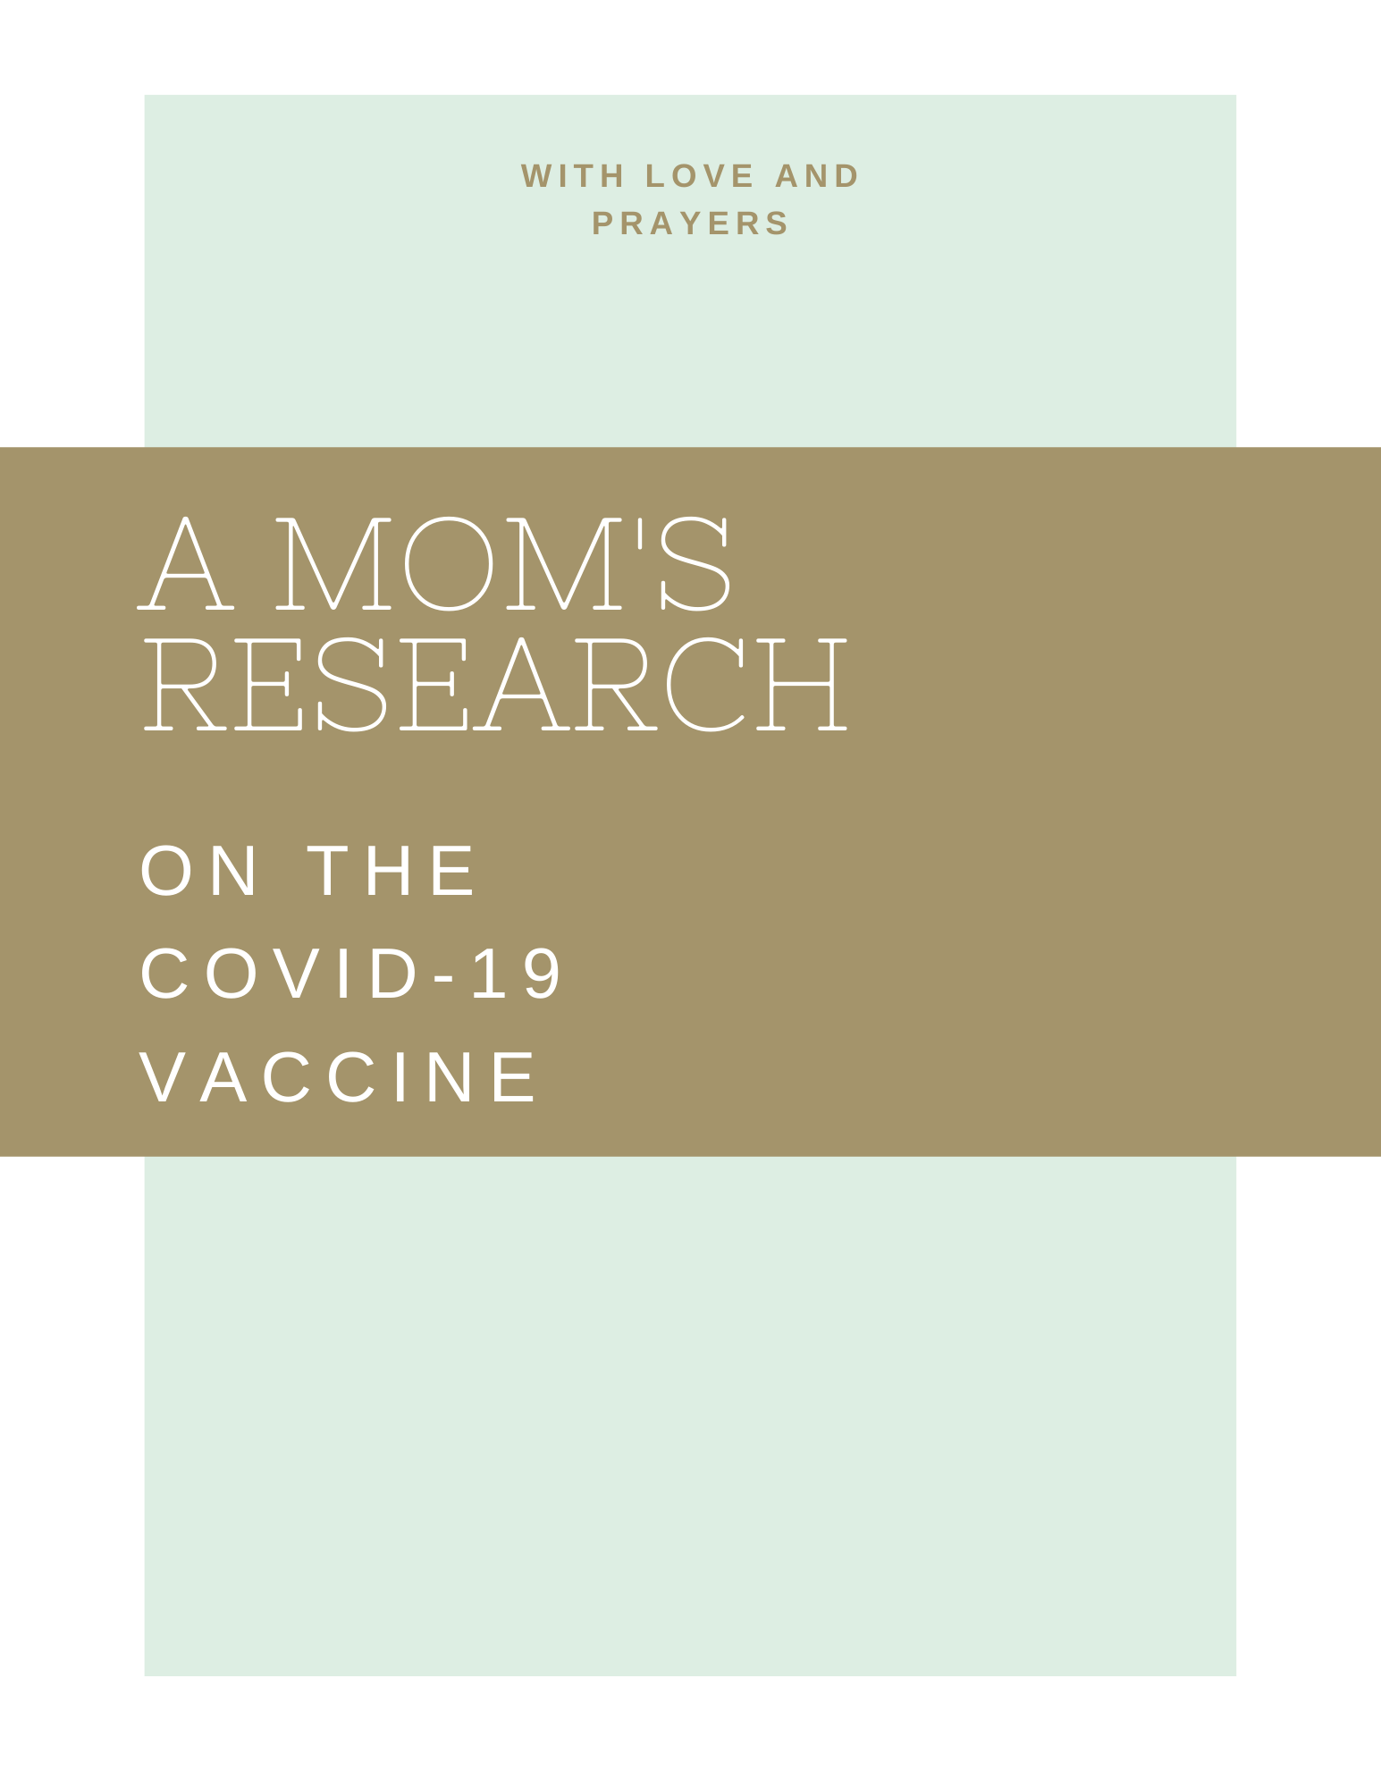
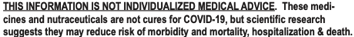
Treatment decisions should be made between a patient and physician.
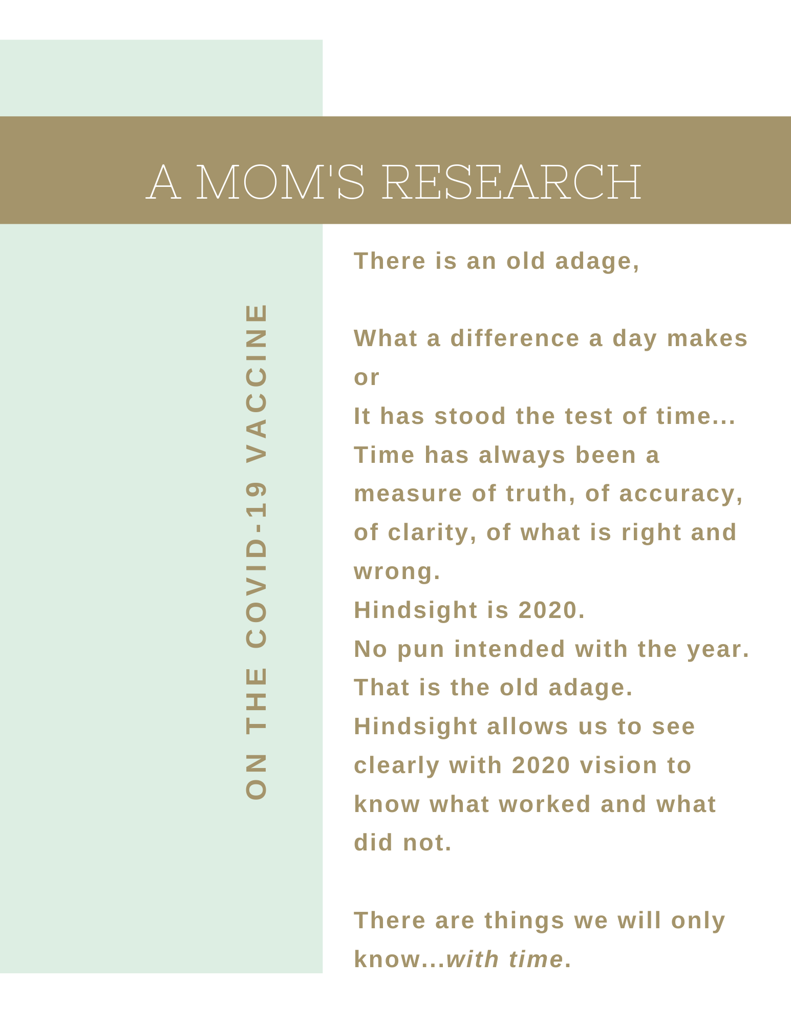

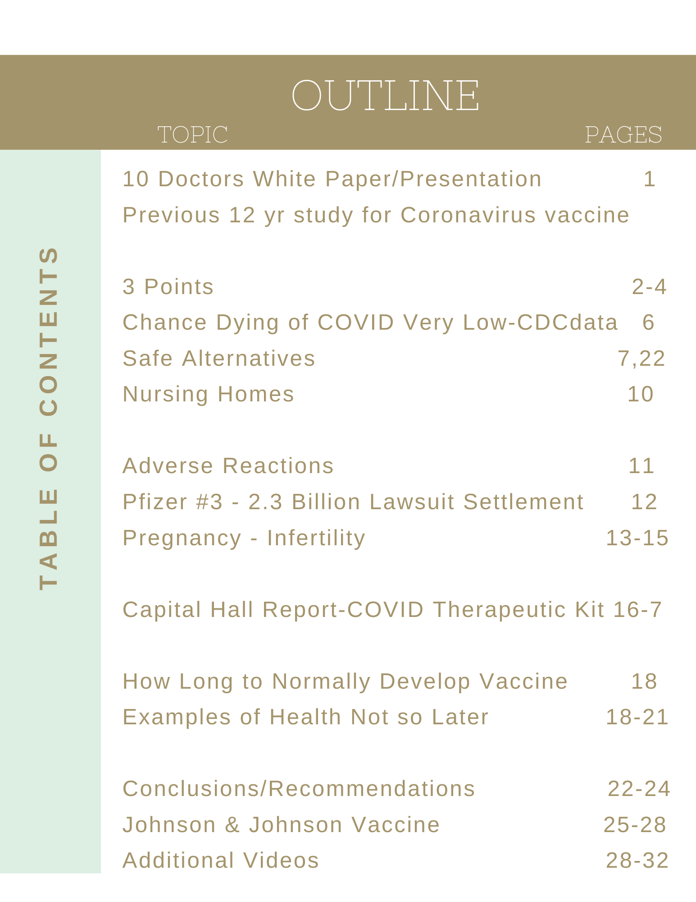

“Intellectual freedom is essential to human society:
Freedom to obtain and distribute information, freedom for open minded and unfearing debate, freedom from pressure from officialdom for freedom of thought.”
- Russian dissident Andre Sakharov

Why I am writing this:

Love is the greatest of all things. It is what drives us, moves us, comforts us and soothes us. This paper is written with my heart, with love and even a few tears. We are in such a difficult time, searching for answers to get out of it. Freedom of speech and freedom of thought are a crux of our great nation. It helps us make decisions. Someone passed on information to me. I was so glad to receive it in making such important decisions. I wanted to pass on information to you.

With care, love and prayers for your decisions,

A mom, who is also a daughter

(Also, I am writing this with concern as voices are being suppressed and slandered. I saw this beginning over 5 years ago and thought it was bad then, but it seems tremendously worse now.)

Please note there are many links in this document. Because of the extreme increase in censorship, DuckDuckGo is a good search engine that may have links others don’t and it protects searcher’s privacy.

For me it started with friends sending me this presentation below. What I find most critical and urgent in the presentation is her information on the experimental COVID vaccine. The links are here with a 3 points summary below and more detailed points later. Her information is from 10 doctors with combined over 100 years of experience working for a month gathering information. (White paper link includes research backup links.)

White paper by 10 doctors. https://img1.wsimg.com/blobby/go/99d35b02-a5cb-41e6-ad80-a070f8a5ee17/SMDwhitepaper.pdf

Presentation on white paper: The Stand: the vaccine for COVID-19 is experimental.

Below, this (5 min) video below is a good data point to know about. (Note subtitles at times.)
PREVIOUS TESTING ON CORONAVIRUS VACCINE
Robert F. Kennedy Jr. and Del Bigtree on how research testing was tried for 12 years for a Coronavirus vaccine, but it was unsuccessful and fatal.
The Coronavirus Vaccine Uncensored | Robert F. Kennedy Jr. & Del Bigtree

Trump was at 900,000 vaccines a day, Biden is planning on 1 million vaccines a day; 100 million in his first 100 days or one third the population of US.

Three Summary Points from first video listed and the white paper:

Point 1 – The vaccine is experimental, because there is no long-term data.
The COVID vaccine is NOT approved as a finished vaccine by FDA but only as investigative = experimental (even though called a vaccine, it is an experimental vaccine).
The experimental COVID vaccine has no long-term data and, therefore, should not be pronounced safe and effective. That has always been standard medical practice. Normally a vaccine takes 5-15 years to be approved. More information page 16.

Point 2 – The long-term data on vaccine attempts for SARS-CoV-1, that is 78% the same as SARS-CoV-2 (COVID-19), was a tremendous failure and even fatal. At first things look good and immunity is built, but there was “antibody dependent enhancement” or “pathogen priming” where the antibodies keep building and it caused the animals (and humans with dengue fever – more on pg. 20) to get the sickness (coronavirus) more severe than if they have not had the vaccine and can be suddenly fatal.
(FYI - There is also concern based on how it works with the placenta that it may cause infertility again longer term. CDC (Jan 29) is reporting 13 miscarriages from the vaccine.) No pregnant women were in the trails. More information below.

From White Paper: (link above)
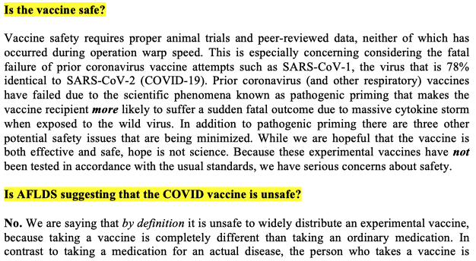
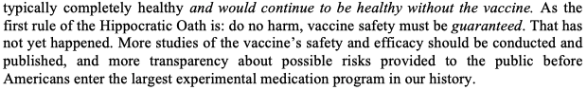

Quote from above: “Vaccine safety must be guaranteed.”

The outline is like a list of concerns:
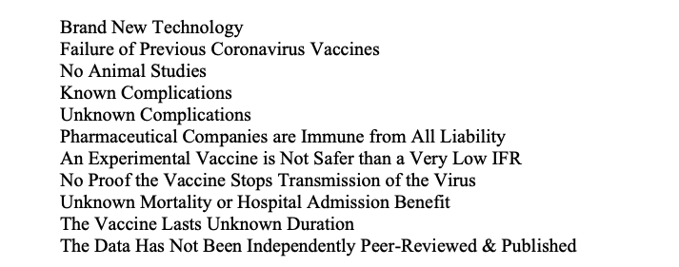

Infertility long term unknown (13 miscarriages as of Jan 29 more detail on this below)
from white papers again below
The mechanism of action of the experimental mRNA vaccines includes a possible autoimmune rejection of the placenta. In layman’s terms, the vaccine may permanently interfere with a woman’s ability to maintain a pregnancy. The vaccine companies themselves acknowledge the possibility of ill effects on a pregnancy on the vaccine bottle, which says the following: “it is unknown whether COVID-19 mRNA VaccineBNT162b2 has an impact on fertility. And women of childbearing age are advised to avoid pregnancy for at least two months after their second dose.”30

Dr. Wolfgang Wodarg and Dr. Michael Yeadon, the former head of Pfizer research, filed an emergency STAY OF ACTION with the European Medicines Agency trying to prevent the experimental COVID mRNA injections from being used on the public as guinea pigs.
Excerpt from above: STAY (of COVID vaccine) URGENTLY REQUIRED I. Petitioner and many EU residents/citizens will suffer irreparable harm because once the EMA approves the COVID- 19 vaccine(s) in question, both governments of EU member states and employers in the EU are most likely going to recommend them for widespread use, and hence without the EMA assuring proper safety trials of the vaccines now, the Petitioner and others will not have the opportunity to object to receiving the vaccine based on deficient clinical trials later. II. Furthermore, if the vaccines are licensed without an appropriate efficacy review and without improving the accurate determination of primary endpoints, then any potential acceptance or mandate of these vaccines are likely to be based on inaccurate beliefs and data about the vaccines, namely that they will or might stop transmission of the virus from the vaccine recipient to others and/or that it will reduce severe COVID-19 disease and deaths. The trial protocols in question are not currently properly designed to determine whether either of those objectives can be met.

Do we want ourselves or loved ones to be in a human experimental medical trial? What is known as being a guinea pig. This is experimental. At minimum shouldn't we wait and watch results long term? Even if one takes the vaccine, Fauci and others are saying it is not known if the vaccine will decrease transmission so we will NOT get to stop wearing masks etc. or travel. - AND there are safe alternatives.

Point 3 - There are other safe preventatives and effective treatments with known long-term safety for decades.

With natural immunity and these available safe and effective treatments – there is no need to take the vaccine. Budesonide has been proven 90% effective! https://budesonideworks.com/validation/
Ivermectin results had 100% effective preventative for healthcare workers.
Dr. Pierre Kory before Senate hearing on Ivermectin Ivermectin is decades long known safe.

These treatments and others have not been used to the extent they should so far on COVID. How many deaths could have been prevented with these early treatments or even used when patients are severely ill? One reason these treatments have not been used may be political. Another reason could be because the information is being suppressed. But one of the main reasons may likely be, with the disease being new, the NIH had recommended staying home until the patient was really sick and needed to be hospitalized. The Association of American Physicians and Surgeons states:
“The current NIH guidelines convey therapeutic nihilism by recommending NO specific treatment until shortness of breath requires hospitalization. Ethical practicing physicians reject the fatalistic NIH recommendations.” See following for flyer that this quote came from.
Copy of the Association of American Physicians and Surgeons COVID-19 Protocol Flyer HERE These treatments work better the earlier taken, although they do work with success even for patients in severe cases.
More Detail:
Budesonide, inexpensive, readily available, and a very safe treatment used for asthma for years, has been found 90% effective! Most recent study by Oxford University
https://www.ox.ac.uk/news/2021-02-09-common-asthma-treatment-reduces-need-hospitalisation-covid-19-patients-study https://budesonideworks.com/validation/

https://www.bitchute.com/video/FHTyW1dGLsBK/ Must Watch 22 min Budesonide
The information in the clip above is important for anyone even if they have had the vaccine since it does not prevent COVID and it is important to know effective treatment if one does get ill or a loved one gets ill. Also the information on early treatment in the AAPS Flyer above is important to know. People may want to have things from AAPS Flyer on hand or even take preventively when traveling or seeing family
https://budesonideworks.com
Ivermectin
Dr. Pierre Kory before Senate hearing This link should be watched in its entirety. It shows how successfully and safely something used for decades has worked.

Here are studies of what has been found to help: Click link. Click top bar or hover at bottom of chart to scroll to more pages.
Latest International Testing This shows worldwide testing updated. One can click on HCQ or Vit D or Ivermectin or Remdesivir... Click on top bar for each.
Hover near the bottom of the first picture and click the arrow to go to the next slides.

Going back to the first mentioned white paper and COVID presentation (links: Pg.1)
My Notes: (These are my notes on the white paper and presentation. I am not a medical physician.) (Above was a point summary and this is a bit more detail.)

1. This is brand new technology never used before (not a normal vaccine) - mRNA technology. This has NOT been approved as a vaccine. It is experimental. It is in the investigation stage only. (Do you want to be the first one to take brand new things when it comes to medicine?) (Johnson & Johnson discussed at the end of the report, but almost all issues are the same as there is still potential of antibody dependent enhancement, no long term data, etc.)
2. There has been a tremendous failure of previous attempts at coronavirus vaccines. SARS-CoV 1 is 78% the same as SARS-CoV 2, which is another name for COVID-19. Prior attempts in animals for the first shot and the second shot went fine, but then when the animals were released in the wild, they later died of the “COVID” disease - SARS-CoV 1 that they had had the vaccine for. This is due to antibody dependent enhancement where the mRNA continues building antibodies and instead of the immunity desired long term, it has the alternate effect where you are more susceptible to the disease, where it could be worse for you (even death) then if you have not had the vaccine.
3. There are no independently published data on animal studies. (except for previous studies mentioned above for SARS-CoV 1, which is 78% the same as COVID-19 (also called SARS-CoV 2). The animals died in the previous studies on SARS-CoV 1, although fine after a few months with the two shots.
4. Known possible complications – antibody dependent enhancement or immune enhancement or pathogenic priming - mentioned above.
5. The companies doing the trials and making the vaccine are given immunity.
6. For women of child-bearing age, the vaccine may cause infertility.
7. There are a lot of things we simply don't know. Do you want to take an experimental vaccine where you do not know long term? 3-7 months does not give us long term data.
8. There is no proof, as Fauci and media has pointed out, that this vaccine will stop transmission. So, we would NOT be able to "go back to normal". Travel would still not be recommended and masks and social distancing recommended.
News video with good summary Still No Normal (Excuse the language in this second link, I include it as it shows the point.)
10. There is no proof that this will actually decrease mortality rates.
11. It is not known how long it lasts meaning - You would not know how long you are "protected" by the vaccine
12. If you have a disease you are willing to take a drug to get rid of it, but to give something experimental to all the healthy people is very risky.

"People ask me if I am going to get the vaccine and would I recommend my children take the vaccine. I say it is really irrational to take a brand new, untested, untried technology, when on the other hand, I have a drug that is 65 years old, it has been given billions of times and it is completely safe for all age groups." - Dr. Simone Gold

Recommendation by American Frontline Doctors by age group on getting the vaccine

Information from CDC site - that I pulled Jan 28th
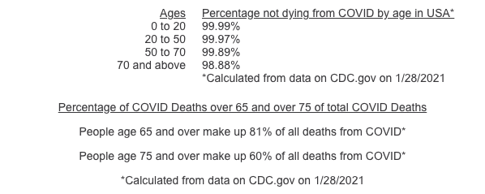
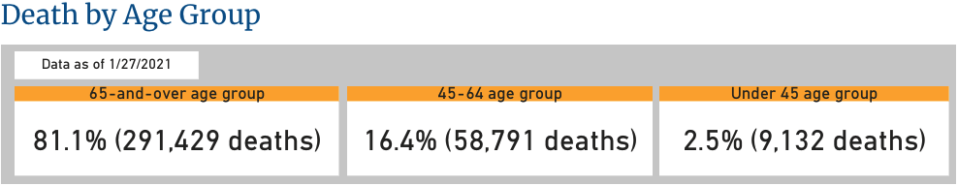
Only 6% of deaths of COVID have no other co-morbidities according to this chart from CDC.

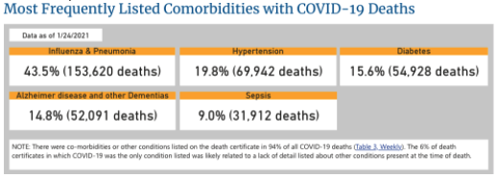
See NOTE at bottom of chart below. With the combination of 81% dying of COVID over 65 and 94% dying from COVID having co-morbidities, therefore for anyone under 65, COVID-19 is a very low risk, especially compared to the untried, untested long-term vaccine. A case could be made that numbers dying from COVID were inflated in that it includes those who would pass away anyway at that time of something else. Dr. Deborah Birx stated as such: https://www.realclearpolitics.com/video/2020/04/08/dr_birx_unlike_some_countries_if_someone_dies_with_covid-19_we_are_counting_that_as_a_covid-19_death.html#!
At Tuesday's White House coronavirus press conference, task force member Dr. Deborah Birx said that while some countries are reporting coronavirus fatality numbers differently, in the U.S. you are counted as a victim of the pandemic if you die while testing positive for the virus, even if something else causes your death.

Why this is important is if the numbers are inflated there is even less need to take the vaccine that either has no long-term data or 78% same Coronavirus data in long-term studies that were tremendous failure including fatal where later many vaccinated ended up with a more severe case of the coronavirus they were vaccinated for. It was better not to be vaccinated.

SAFE ALTERNATIVES

There are safe alternatives.

BUDESONIDE
Budesonide, inexpensive, readily available, and a very safe treatment used for asthma for years, has been found 90% effective! Most recent study by Oxford University
This can keep you out of the hospital and prevent a ventilator.

https://www.bitchute.com/video/FHTyW1dGLsBK/ Must watch Link

https://budesonideworks.com From website:
(See Medical Disclaimer)
- If you have Covid symptoms or test positive, go to the Got Covid? page (stage 2).
- If you were exposed to someone or need help with prevention, go to the Got Covid? page (stage 1).
- If you need to find a provider for the protocol, go to the Providers page.
- If you need help advocating for a loved one with Covid in the hospital, go to the Got Covid? page (stage 3).
- If you need help with “long haulers syndrome” or lingering issues, go to the Got Covid? page (stage 4).
- If you are a doctor who wants proof of the protocol, read the studies and articles on the Validation page and read or watch the doctor and patient testimonials on the Stories page.
- If you are a provider and would like to be included in our network (publicly or privately), go to the Providers page and complete the form.
- If you want to download the full protocol to give to your doctor, you can find it here.

VITAMIN D3
Vitamin D3 is strongly recommended to prevent Coronavirus as 80% of severe patients have low Vitamin D. One needs to be taking a regular dose. Latest International Testing
Association of American Physicians and Surgeons COVID-19 Protocol Flyer HERE
HYDROXYCHOLROQUINE
In an unprecedented situation, false studies in the top major medical journals were retracted on hydroxychloroquine (HCQ). It is basically unprecedented to have false studies get in these journals and unprecedented to have things retracted from them. The CDC (and main stream media) have not updated their information on hydroxychloroquine to reflect that.
Top medical journals, including the Lancet, as never happens, retracted the article saying HCQ was not effective as the test was fraudulent:
https://www.thelancet.com/journals/lancet/article/PIIS0140-6736(20)31180-6/fulltext

One recommendation for safe alternative is Hydroxychloroquine (HCQ) and Zinc as there are many studies proving it is effective and safe as preventative and/or treatment.
Latest International Testing
Millions of people have taken Hydroxychloroquine safely over 65 years.
In the continent of Africa many take HCQ once a week to prevent malaria. Those countries have low COVID-19 rates (as countries/states taking Ivermectin).

The disinformation caused a hydroxychloroquine (HCQ) lockdown in US. In the world 4.6 billion have access to HCQ, many over-the-counter. In Africa it is taken weekly by all ages for malaria. Countries taking HCQ have low COVID-19.

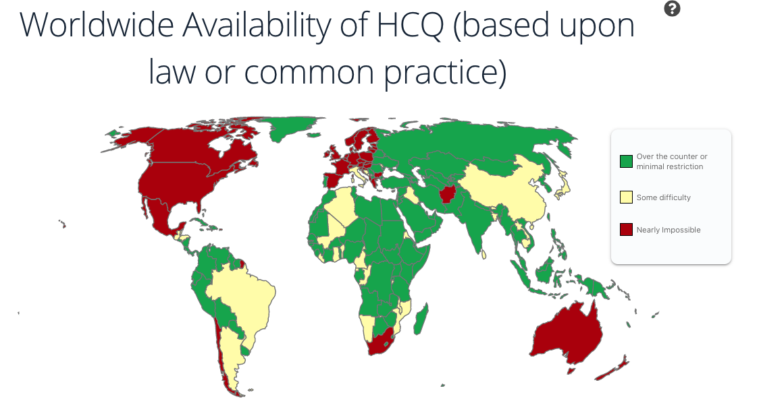

Because of events in 2020 access to HCQ has been restricted in the US. (It is unprecedented to lockdown safe medication.) It is not been prescribed (with Zinc) to the extent it should to prevent COVID-19 and death from the disease. Also, you can give HCQ to the sick versus giving experimental treatment to everyone who is well or give HCQ as safe preventative dose as it has been used for 65 years safely.

LOCKDOWN Map of hydroxychloroquine (HCQ)

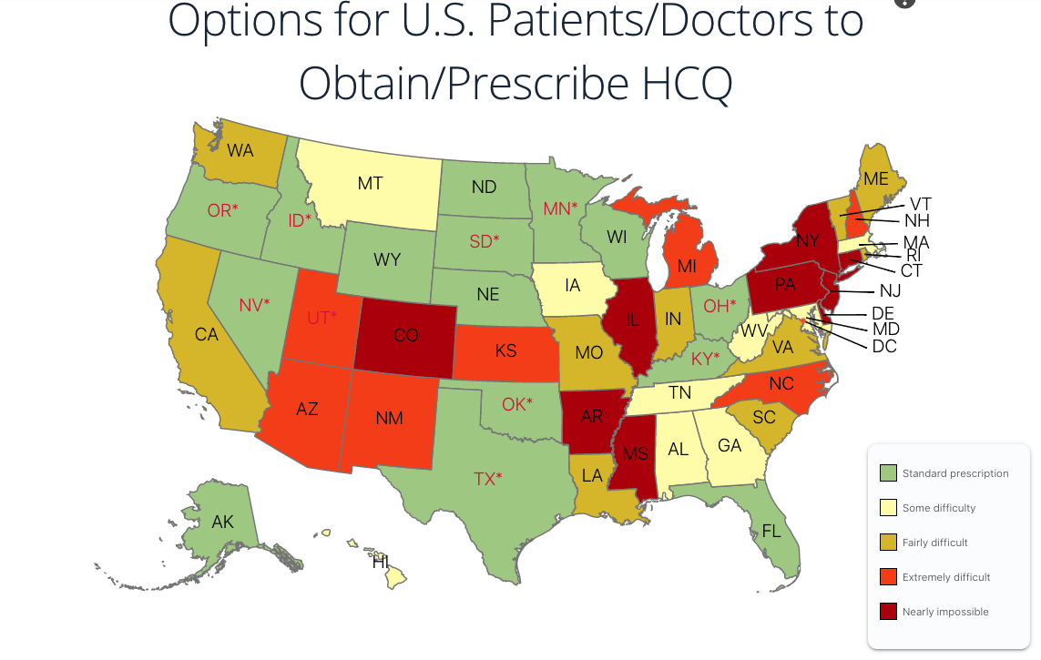

IVERMECTIN

Another drug that is safe and taken for decades given to billions is Ivermectin.
Study summary:
800 health care workers using Ivermectin - none with COVID;
400 health care workers given placebo; NOT given Ivermectin - 58% got COVID.

VERY important clip below on Ivermectin:
Dr. Pierre Kory before Senate hearing (This link was also near the top in the summary points.) Recommended to watch the above link in full.

Latest International Testing (link was listed earlier as well)

This link shows testing for safe alternatives around the world. Click on HCQ or Vit D3 or Ivermectin or Remdesivir... Vitamin D3 daily dose is recommended to prevent.
(There was testing using toxic high doses of HCQ that gave false data now retracted.)

NURSING HOMES
UNREPORTED DEATHS OR VACCINE DEATHS PERHAPS ATTRIBUTED TO COVID

In the link following a man, who is a CNA nurse at a nursing home is saying deaths from the vaccine are not being reported, but being attributed to COVID.

CNA Nursing Home Whistleblower: Seniors Are DYING LIKE FLIES After COVID Injections! SPEAK OUT!!!

http://www.ronpaulinstitute.org/archives/peace-and-prosperity/2021/january/10/a-nursing-home-had-zero-coronavirus-deaths-then-it-vaccinates-residents-for-coronavirus-and-the-deaths-begin/

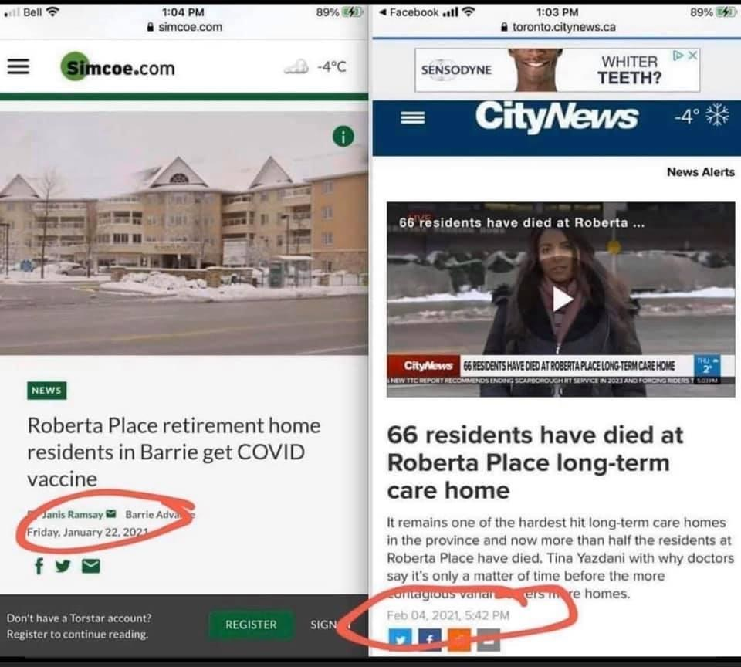

Retired – Former Pfizer Chief Science Officer:
“There is absolutely no need for vaccines to extinguish the pandemic. I’ve never heard such nonsense talked about vaccines. You do not vaccinate people who aren’t at risk from a disease. You also don’t set about planning to vaccinate millions of fit and healthy people with a vaccine that hasn’t been extensively tested on human subjects.” – Dr. Michael Yeardon
https://discover.hubpages.com/politics/Former-Pfizer-Chief-Science-Officer-Says
ADVERSE REACTIONS

Pulled from FDA site (from their Oct. meeting) as to what to look for as possible adverse events:

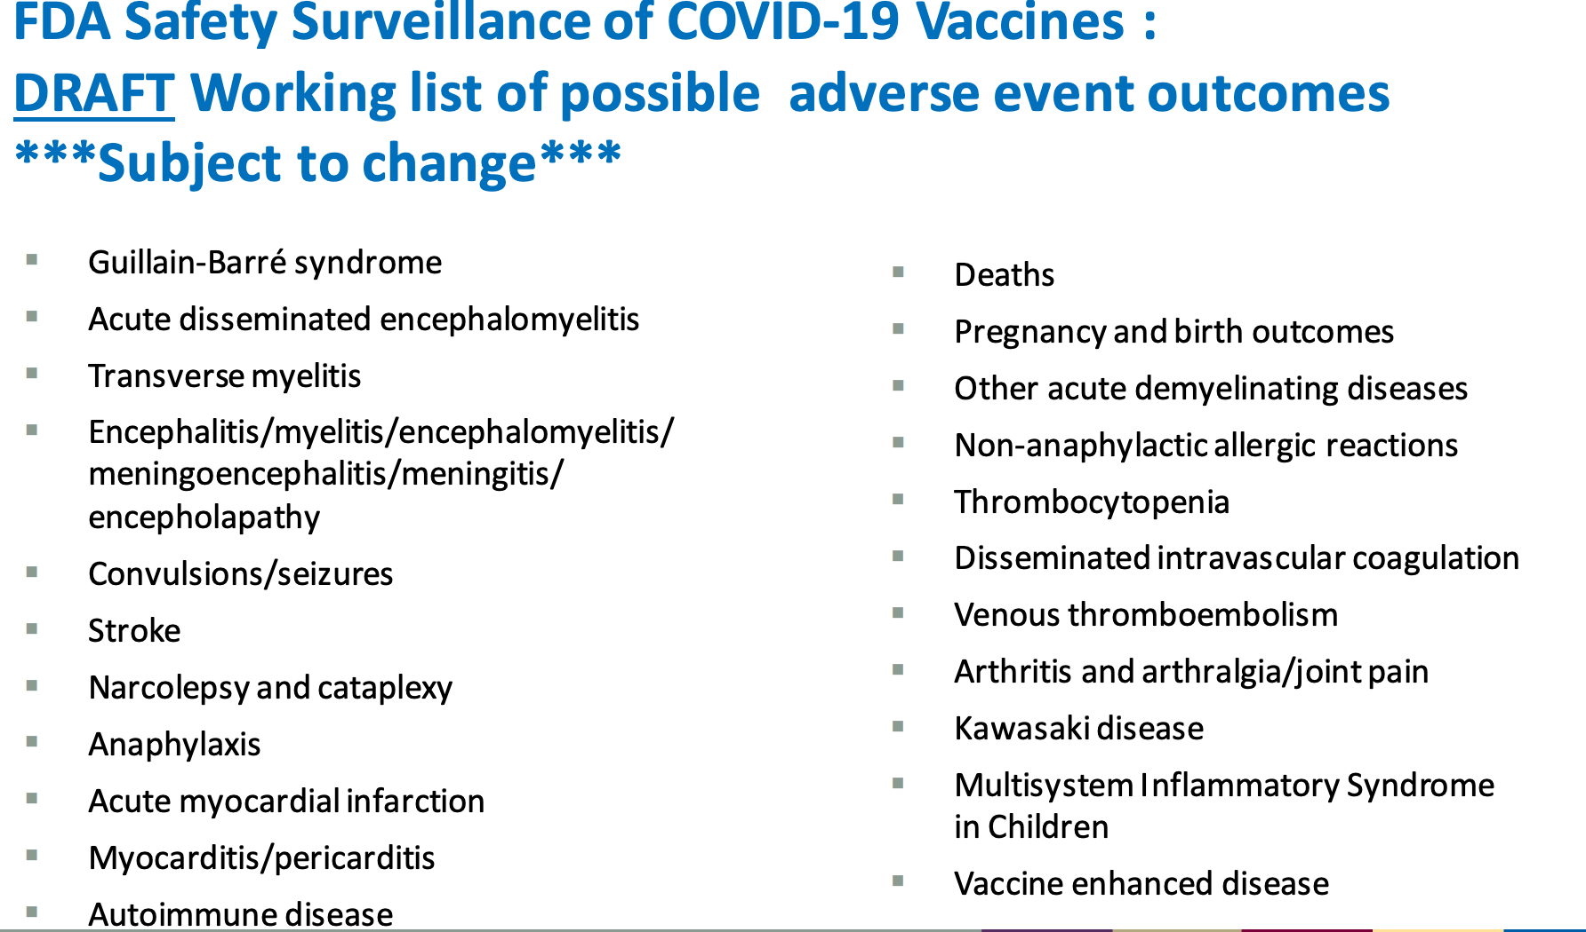

Harvard medical study shows most adverse reactions to vaccines are not reported:

Fewer than 1% vaccine-related reactions are reported.
Barbara Loe Fisher, co-founder and president of the National Vaccine Information Center, says only a fraction of people report their vaccine reactions. She also noted that one federally funded 2011 study found that less than 1% of vaccine-related reactions are reported to the national database.

As of Jan 26, 2021 Deaths reported to CDC from COVID Vaccine:
501 Deaths + 10,748 Other Injuries Reported Following COVID Vaccine, Latest CDC Data Show • Children's Health Defense

Doctors Link Pfizer, Moderna Vaccines to Life-Threatening Blood Disorder

KUTV CBS News on adverse reactions
https://www.facebook.com/watch/?v=1136651613445684

Over 1,000 deaths reported by Feb 26
https://discover.hubpages.com/politics/Former-Pfizer-Chief-Science-Officer-Says
PHARMACEUTICAL COMPANIES PREVIOUS INFRACTIONS AND NOW IMMUNITY

Biggest pharmaceutical lawsuits by settlement amount

Pfizer is #3 with a 2.3 Billion lawsuit settlement payment. For the experimental COVID-19 vaccine we are trusting Pfizer and others, who has been given immunity. They have no liability, while in the past Pfizer have proven lawsuits they have lost. As the article above starts out: "Fraudulent and illegal conduct by pharmaceutical companies poses a great risk to public health and maligns the decisions of healthcare providers, ...
Pharmaceutical-technology lists the ten biggest pharmaceutical lawsuits based on the amount of settlement."

https://financialpost.com/financial-times/why-the-pfizer-ceo-selling-62-of-his-stock-the-same-day-as-the-vaccine-announcement-looks-bad

PREGNANCY AND INFERTILITY
From earlier in the document:

Infertility long term unknown (13 miscarriages as of Jan 29 more detail on this below)
(As noted the Harvard study showed 1% of vaccine reactions reported.)
from white papers again below
The mechanism of action of the experimental mRNA vaccines includes a possible autoimmune rejection of the placenta. In layman’s terms, the vaccine may permanently interfere with a woman’s ability to maintain a pregnancy. The vaccine companies themselves acknowledge the possibility of ill effects on a pregnancy on the vaccine bottle, which says the following: “it is unknown whether COVID-19 mRNA VaccineBNT162b2 has an impact on fertility. And women of childbearing age are advised to avoid pregnancy for at least two months after their second dose.”30

Email on Miscarriages
It is not known if the vaccine could cause long-term infertility based on how it affects the placenta.
Anything in the email below with a VAERS # is from the CDC website on reported reactions to the vaccine. They are online.

What my friend wrote:
I'm truly shocked a doctor who is pregnant would get the vaccine, and this is not the only woman who has suffered a miscarriage the after getting the vaccines.
Please alert your female friends of childbearing years to be so cautious and wise, even if their doctors recommend something. The MSM has suppressed
so much information by highly credentialed doctors. According to Dr. Sherri Tenpenny, we won't know the full reaction to the vaccine for up to a year or so.
Remember the vaccine is experimental, does not stop transmission and the pharmaceutical companies are not liable. Email follows on next page

Wisconsin Resident Doctor has Miscarriage 3 Days After Being Injected with Experimental COVID mRNA Shot

February 10, 2021 2:56 pm

Dr. Sara Beltrán Ponce graduated from the Medical College of Wisconsin in 2019. She is completing her residency in Radiation Oncology at the same Milwaukee college. Her profile on a website called SheMD says she is “passionate about medical education, public health, and mentorship, particularly for women interested in radiation.” She is married with one daughter and had another child on the way – until yesterday. Dr. Beltrán Ponce tweeted on January 28 that she is 14 weeks pregnant and “fully vaccinated.” She repeated many of the most common talking points related to COVID-19 and vaccines in the tweet chain. She tweeted an update about her pregnancy less than a week later, stating that she had a miscarriage. The miscarriage happened at 14 1/2 weeks, indicating it was three days after she got the first or second mRNA shot. As you can see from Dr. Sara Beltrán Ponce's update tweet announcing the death of her unborn baby, she didn't dare connect it to the COVID injection, because to do so would have probably shipwrecked her career as a medical doctor, because she would have been labeled as an "anti-vaxxer" and therefore "anti-science."

by Brian Shilhavy
Editor, Health Impact News
The COVID Blog, part of COVID Legal USA which is “a team of paralegals, legal writers and researchers helping Americans represent themselves in legal matters against oppressive, dangerous COVID mandates,” has reported on the miscarriage of a Wisconsin doctor shortly after receiving one of the experimental COVID mRNA injections.
Dr. Sara Beltrán Ponce graduated from the Medical College of Wisconsin in 2019. She is completing her residency in Radiation Oncology at the same Milwaukee college. Her profile on a website called SheMD says she is “passionate about medical education, public health, and mentorship, particularly for women interested in radiation.” She is married with one daughter and had another child on the way – until yesterday.
Dr. Beltrán Ponce tweeted on January 28 that she is 14 weeks pregnant and “fully vaccinated.” She repeated many of the most common talking points related to COVID-19 and vaccines in the tweet chain.

She tweeted an update about her pregnancy less than a week later (NOTE: There is a narrative on social media channels about some sort of “fake photo” in Dr. Beltrán Ponce’s tweets. The narrative appears to attempt discrediting the story or deflecting from the facts. We’ve linked the internet archives herein for readers to see the actual tweets and screenshots).

The miscarriage happened at 14 1/2 weeks, indicating it was three days after she got the first or second mRNA shot. She did not say if it was the Pfizer or Moderna shot. Dr. Beltrán Ponce has since locked her Twitter account so only verified followers can see her tweets. (Full article.)
In searching through the CDC Vaccine Adverse Event Reporting System (VAERS), I found a few other reported cases of miscarriages so far just after receiving the Pfizer experimental COVID shot. One of them, in California, was also a doctor.
VAERS ID: 918034
Write-up: I was 28 weeks and 5 days pregnant when I received the first dose of the COVID19 vaccine. Two days later (12/25/2020 in the afternoon), I noticed decreased motion of the baby. The baby was found to not have a heartbeat in the early am on 12/26/2020 and I delivered a 2lb 7oz nonviable female fetus at 29 weeks gestation. I was 35 years old at the time of the fetal demise and the only pregnancy history for this pregnancy included a velamentous cord insertion that was being closely monitored by a high-risk OB. My estimated due was March 12, 2021.
VAERS ID: 958755
Write-up: Pt was 18 weeks pregnant at the time of the vaccine. Second pregnancy. Pt is a physician. Pregnancy was entirely normal up to that time. On 1/18/2021, she began to have heavy vaginal bleeding probably due to a placental abruption and subsequently delivered at 18 weeks. Baby was stillborn. Ultrasound done 1/15/2021 normal. Lethal event for the fetus. The patient did well.
VAERS ID: 967274
Write-up: I was pregnant and my baby died two days after I took it and I got really sick
As we have previously reported, when the UK issued its emergency use authorization (EUA) for the Pfizer COVID mRNA injection, they recommended that pregnant women NOT get the jab. They also recommended that nursing mothers and women planning on becoming pregnant to wait at least two months.
The FDA in the United States, however, issued no such warnings when they issued an EUA for the same experimental Pfizer COVID mRNA injection. See:

Unlike UK, U.S. FDA Allows Pregnant and Nursing Women to Receive Experimental Pfizer COVID Vaccine
Dr. Wolfgang Wodarg and Dr. Michael Yeadon, the former head of Pfizer research, filed an emergency STAY OF ACTION with the European Medicines Agency trying to prevent the experimental COVID mRNA injections from being used on the public as guinea pigs.
One of Dr. Yeadon’s primary concerns was that the experimental jabs would cause infertility. He wrote that these injections are still in Phase III trials and are:
expected to induce the formation of humoral antibodies against spike proteins of SARS-CoV-2. Syncytin-1 (see Gallaher, B., “Response to nCoV2019 Against Backdrop of Endogenous Retroviruses” – http://virological.org/t/response-to-ncov2019-against-backdrop-of-endogenous-retroviruses/396), which is derived from human endogenous retroviruses (HERV) and is responsible for the development of a placenta in mammals and humans and is therefore an essential prerequisite for a successful pregnancy, is also found in homologous form in the spike proteins of SARS viruses.
There is no indication whether antibodies against spike proteins of SARS viruses would also act like anti-Syncytin-1 antibodies. However, if this were to be the case this would then also prevent the formation of a placenta which would result in vaccinated women essentially becoming infertile.
To my knowledge, Pfizer/BioNTech has yet to release any samples of written materials provided to patients, so it is unclear what, if any, information regarding (potential) fertility-specific risks caused by antibodies is included.
According to section 10.4.2 of the Pfizer/BioNTech trial protocol, a woman of childbearing potential (WOCBP) is eligible to participate if she is not pregnant or breastfeeding, and is using an acceptable contraceptive method as described in the trial protocol during the intervention period (for a minimum of 28 days after the last dose of study intervention).
This means that it could take a relatively long time before a noticeable number of cases of postvaccination infertility could be observed. (Source.)
As you can see from Dr. Sara Beltrán Ponce’s update tweet announcing the death of her unborn baby, she didn’t dare connect it to the COVID injection, because to do so would have probably shipwrecked her career as a medical doctor, because she would have been labeled as an “anti-vaxxer” and therefore “anti-science.”

Email from Texas Senator Bob Hall
Capitol Hall Report - COVID Therapeutics Kit

Notes from those sending the email:
I thought it important to note what Senator Hall says: "with confidence in efficacy of the vaccines declining daily"

It is important to let our friends know as they are giving out 1 million vaccines a day. There are other SAFE, KNOWN options. per what was sent below. I love how he says - Let's take the "Offensive Strategy" Great safe options click the highlighted link HERE

A copy of the AAPS COVID-19 Protocol Flyer can be found HERE.

Excerpt here:

“Substantial worldwide evidence reveals multiple treatment options. Physicians worldwide are prescribing therapies that are effective at reducing hospitalization and death from COVID-19. They have reason to be hopeful based on the clinical experience and studies. The current NIH guidelines convey therapeutic nihilism by recommending NO specific treatment until shortness of breath requires hospitalization. Ethical practicing physicians reject the fatalistic NIH recommendations. The following stages of treatment have been studied and expert scientific opinions support treatment at these stages prior to hospitalization.”

Here is an email from Texas State Senator Bob Hall that gives us ideas of what to take to prevent Covid...or perhaps a worse case of it, if we get it. He provided personal COVID kits for each of the other State Senators. Everyone should be on vitamin D3 daily dose as 80% of severe Covid patients were low in Vitamin D3.
Subject: Capitol Hall Report - COVID Therapeutics Kit
From Senator Hall

Our “Defensive Only Strategy” has allowed COVID-19 to kill too many people. The masks, lockdowns, and isolation policies are unnecessarily destroying our economy. And, with confidence in the efficacy of the vaccines declining daily, it is far past time we switched from a “Defensive Strategy” to an “Offensive Strategy”. We can make this switch by following the recommendations of the Association of American Physicians and Surgeons (AAPS) COVID-19 Preventative and Early Protocols.
We are so convinced of the effectiveness of these protocols that, today, we gave each of the Texas Senators a personal “COVID-19 Combat Kit” which included at least a month’s supply of vitamin C, vitamin D3, Zinc, Quercetin, and the AAPS instructional flyer.
A copy of the AAPS COVID-19 Protocol Flyer can be found HERE.
Text below from the note to the Senators I described in this video:
“Senator
I hope you will find this COVID prevention therapeutics kit as comforting as I did. This kit is based on the recommendations of the Association of American Physicians and Surgeons (AAPS). It is similar to the kits being distributed internationally by several countries like Costa Rica, India and Honduras to their citizens. The effectiveness of which is confirmed by their death rate being only a small fraction of that which we have had in the USA and Texas.
I have worked with the frontline clinical doctors who developed these protocols since last May and know, firsthand, their effectiveness.
I am not a doctor and I am not offering medical advice. I simply want to share with you what I am doing for myself and my family because I know that there is a large part of the medical community that wants us to think that the only things you can do are wear masks, socially distance and isolate.
Please know that I have sent this therapeutics kit to you because I genuinely care about you and all of my fellow legislators. I want us to have a safe and successful session that is as near to normal as possible.
May God continue to bless you.
p.s. If you have achieved COVID immunity, feel free to pass this on to a loved one.”
It is past time to return to the principles of life, liberty, individual pursuit of happiness, and personal responsibility to the people. It is time for the government to return to governing and not ruling. We have good offensive solutions to combat COVID-19. It should be obvious to everyone that it is well past time for Texans to get back to the “old normal” and stop being forced to accept a "new normal."

HOW LONG TO DEVELOP VACCINE

How long usually to develop a vaccine on Google shows 10 to 15 years or 5 to 10 years.

Per below:
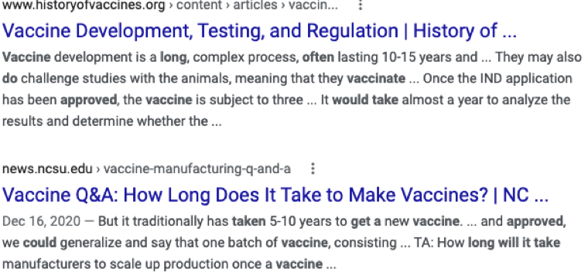

The COVID testing to arrive at 95% effective was in Pfizer’s case originally 28 days definitely under 3 months. One complaint is that later data of comparison to show how many in the trials that have since had COVID is not being either released or perhaps not being tested. From the trials it did show you can still get COVID if you have had the vaccine.

EXAMPLES of THINGS BELIEVED GOOD FOR HEALTH that were NOT SO LATER

Here are a few examples of things everyone in the world or a large group took as healthy or safe and effective that later turned out not to be good for you or caused or worsened the problem they were said to fix and, in some cases, even deadly.

DIET SODA
The Coca-Cola Company introduced Diet Coke to great fanfare in 1982, following another low-calorie cola called Tab that was produced in 1963.
A growing body of evidence suggests that diet soda consumption correlates with an increased risk of a wide range of medical conditions, notably: heart conditions, such as heart attack and high blood pressure. metabolic issues, including diabetes and obesity. brain conditions, such as dementia and stroke. Jul 31, 2019 Google
People were not told about these problems in 1982 or even later. Diet sodas were marketed to keep weight off, and yet actually caused obesity.
A 2015 study in the Journal of the American Geriatrics Society found that diet soda drinkers age 65 and older actually gained triple the abdominal fat compared to their peers who didn’t consume the drink.
A 2016 study published in JAMA Pediatrics examined more than 3,000 pregnant women and their infant children one year after birth. Mothers who drank diet soda were two times more likely to have obese and overweight children.
The researchers behind a 2017 study gathered data that indicated a link between diet soda and the risk of stroke and Alzheimer’s disease. The study involved 2,888 people over the age of 45 years.

OPIOIDS

How did the opioid epidemic become the nation’s deadliest crisis?
Back in the early 90s, The Joint Commissioner advocated for pain to become the 5th vital sign. This prompted physicians and pharmaceutical companies to find a solution for patients suffering from chronic pain. Once the so-called miracle drug OxyContin was approved by the FDA, master marketing campaigns and false research ensured that every patient had access to these narcotic pain killers. In 2012, there was a bottle of OxyContin for every adult American. That’s over 259 million prescriptions floating around, available for diversion and misuse by the general population. *
https://www.shatterproof.org/blog/10-things-you-need-know-about-opioid-epidemic?gclid=CjwKCAiAp4KCBhB6EiwAxRxbpNm4rx9EeBrDs4zh4bh-w_o5V3dHwXLiOwlmtNnBDa0_IAptgIHxXRoCX-0QAvD_BwE

Mayo Clinic:
The opioid crisis that exists today developed over the past 30 years. The reasons for this are many. Good intentions to improve pain and suffering led to increased prescribing of opioids, which contributed to misuse of opioids and even death. Following the publication of a short letter to the editor in a major medical journal declaring that those with chronic pain who received opioids rarely became addicted, prescriber attitude toward opioid use changed. Opioids were no longer reserved for treatment of acute pain or terminal pain conditions but now were used to treat any pain condition. Governing agencies began to evaluate doctors and hospitals on their control of patients’ pain. Ultimately, reimbursement became tied to patients’ perception of pain control. As a result, increasing amounts of opioids were prescribed, which led to dependence. When this occurred, patients sought more in the form of opioid prescriptions from providers or from illegal sources. Illegal, unregulated sources of opioids are now a factor in the increasing death rate from opioid overdoses. Stopping the opioid crisis will require the engagement of all, including health care providers, hospitals, the pharmaceutical industry, and federal and state government agencies
https://www.mayoclinicproceedings.org/article/S0025-6196(17)30923-0/pdf

THALIDOMIDE

After 60 years, scientists uncover how thalidomide produced birth defects

More than 60 years after the drug thalidomide caused birth defects in thousands of children whose mothers took the drug while pregnant, scientists at Dana-Farber Cancer Institute have solved a mystery that has lingered ever since the dangers of the drug first became apparent: how did the drug produce such severe fetal harm?
Just as the drug's effect in the womb seems totally random, so too was the compensation received. *

https://www.dana-farber.org/newsroom/news-releases/2018/after-60-years--scientists-uncover-how-thalidomide-produced-birth-defects/#:~:text=The%20result%20is%20the%20spectrum,from%20reports%20in%20medical%20literature.


https://helix.northwestern.edu/article/thalidomide-tragedy-lessons-drug-safety-and-regulation
Thalidomide first entered the German market in 1957 as an over-the-counter remedy, based on the maker’s safety claims. They advertised their product as “completely safe” for everyone, including mother and child, “even during pregnancy,” as its developers “could not find a dose high enough to kill a rat.” By 1960, thalidomide was marketed in 46 countries, with sales nearly matching those of aspirin.
Around this time, Australian obstetrician Dr. William McBride discovered that the drug also alleviated morning sickness. He started recommending this off-label use of the drug to his pregnant patients, setting a worldwide trend. Prescribing drugs for off-label purposes, or purposes other than those for which the drug was approved, is still a common practice in many countries today, including the U.S. In many cases, these off-label prescriptions are very effective, such as prescribing depression medication to treat chronic pain.
DENGUE FEVER

As I understand it this is a mRNA vaccine on a similar like virus to Coronavirus as it is respiratory. Note how those who got the vaccine later developed a severe case of the exact illness they were vaccinate for. It was worse than if they had not had the vaccine. It was given to 700,000 schoolchildren under the age of 18 and 50,000 adults.
- The vaccine manufacturer, Sanofi Pasteur, announced in 2017 that people who receive the vaccine…may be at risk of developing severe dengue if they get dengue after being vaccinated.*
https://www.cdc.gov/dengue/prevention/dengue-vaccine.html#:~:text=In%20May%202019%2C%20Dengvaxia%C2%AE,confirmed%20prior%20dengue%20virus%20infection.
In April 2016, the DOH, launched the dengue vaccination campaign in Central Luzon, Calabarzon and Metro Manila, where about 700,000 individuals (my note from other sources is that these were mostly children and 50,000 adults) received at least one dose of the vaccine.^{[11]} The government paid P3.5-billion for the vaccine.^{[10]}
On November 29, 2017, French drugmaker Sanofi Pasteur released a statement stating that their Dengue vaccine, Dengvaxia, posed risk to individuals vaccinated without having a prior dengue infection.^{[12][13]} This came sometime after reports circulated of children dying allegedly from complications associated with the vaccine.^{[5]} Soon after, the Philippine Department of Health (DOH) suspended the vaccination on FCS program based in schools owing to the said concern,^{[14]} with DOH Secretary Francisco Duque saying "In the light of this new analysis, the DOH will place the dengue vaccination on hold while review and consultation is ongoing with experts, key stakeholders and the World Health Organization."^{[11]} On December 2, 2017, the government of Makati immediately suspended its anti-dengue vaccination drive following its statement.^{[15]}
In its statement, pharmaceutical company Sanofi Pasteur reported concerns that Filipinos, mostly schoolchildren, could potentially be at risk of a more severe disease, where the recipient of the vaccine had not had a previous dengue infection; however, a medical director of Sanofi said that the dengue vaccination would not cause "severe dengue." ^{[16]} On December 4, 2017, Sanofi also denied that they made Filipinos into “guinea pigs,” explaining that the vaccine program was conducted by the DOH and not them https://en.wikipedia.org/wiki/Dengvaxia_controversy

The link below was on page 3 of this report as well.
Robert F. Kennedy Jr. and Del Bigtree on how research testing was tried for 12 years for a Coronavirus vaccine, but it was fatal. (This 5 min link should be watched in full.)

The Coronavirus Vaccine Uncensored | Robert F. Kennedy Jr. & Del Bigtree

Conclusions/Recommendations on the following page.

CONCLUSIONS/RECOMMENDATIONS

- To me, these issues with the COVID vaccines make them dangerous and unsafe:
  - There is no long-term data. Transparency is also lacking in the data now with articles saying there are no deaths when VAERS on CDC is reporting over 1,000 and over 10,000 adverse reactions including tremors, strokes and miscarriages. The 2011 Harvard study showed only 1% of adverse reactions to vaccines are reported to VAERS.
  - The long-term data on the vaccine attempts for over a decade and millions of dollars with Coronavirus 78% the same as COVID-19 was a terrible failure with animals dying from the disease they were inoculated for, as well as, in 2017 the vaccine for Dengue fever on 700,000 (mostly school children under 18) was suspended after 18 months because those vaccinated were getting a more severe case of the very disease they were vaccinated for and 600 died. This is due to antibody dependent enhancement or pathogen priming where antibodies continue to build (no off switch) causing more susceptibility to the disease and a severe case and death. At first, meaning after the first two shots the animals and humans do great and it seems to work wonderfully until later or when exposed to the disease later. In the information in later pages on the Johnson & Johnson vaccine, antibody dependent enhancement is also a possibility there.
  - The vaccine may cause permanent infertility. (The long-term data is not there to know differently.)
  - The companies we are trusting in have a track record of prior lawsuits and are given immunity or no liability. (See next pages for Johnson & Johnson)
  - Most people have over 95% “immunity in a sense” already. (Per chart following) Too risky to give an experimental vaccine to those who are well. Safer to treat those who are sick with treatments already proven safe long-term.
  - It does not stop transmission as proven in the trials as people did get COVID.
Information from CDC site - January 28th
  - With the combination of the first chart above showing low chance of dying from COVID for all those under 70, 81% dying from COVID over 65 and 94% of them having a co-morbidity, plus as Dr. Brix said USA counted all who died with COVID (not only those who died from COVID). It does not make sense for all who are well and especially for any under 70 to have the vaccine with the long-term risk.

- There are safe, inexpensive alternatives used for decades by millions. Early treatment before hospitalization is recommended. One can have one of the safe alternatives on hand; meaning Ivermectin or hydroxychloroquine and zinc or perhaps the asthma medication, Budesonide, to take if you test positive with COVID and feel ill. This link HERE will take you to a copy of the Association of American Physicians and Surgeons (AAPS) COVID-19 Protocol Flyer HERE on recommended amounts Or, if you want to wait until you get ill, find a doctor now or someone to get it from, if you do get ill. AAPS does not agree with NIH guidelines to wait until you are having shortness of breath and need hospitalization. They recommend the early treatment. This also lists preventative doses to take if desired.
- But I want to get out of jail – travel, see friends and family and back to normal life.
If you have already had COVID, studies are showing minimal chance of getting it again. If you have not had COVID, and would like to take a preventative dose, as in point 2 above, the recommendations of the Association of American Physicians and Surgeons (AAPS) COVID-19 Preventative and Early Protocols COVID kit are shown next page and link HERE. See prevention dosages for super safe prevention to take all the time or before and while going to see friends and family. Ivermectin taken as a preventative by 800 healthcare workers 100% of them did not get COVID. The placebo given to 400 healthcare workers 58% of them got COVID. (Among many other international studies.) Used for decades and millions, perhaps billions of people safely, Ivermectin and the hydroxychloroquine and zinc listed are shown as great preventative doses to not getting COVID. If you want to see family you can take these before, during and after. Or you can just know that you can take them or budesonide if you get sick. One would not have to take them as long-term preventative unless desired. Vitamin D3 is strongly recommended to be on a daily dose as 80% of people with severe COVID had low vitamin D. Daily Vitamin C is good as well.
Even though the flyer above mentions the vaccine (IF safe), from my research, I (a mom) strongly do not recommend the vaccine in anyway.

- But I and my kids need to get the COVID Vaccine to stop the spread.
People have pulled together, locked down, worn masks, lost jobs and worked hard to stop the spread. It is proven the vaccine will not stop transmission or the spread. We might hope it does some, but we should not take an IRREVERSIBLE vaccine on perhaps the chance of helping someone else. That someone else would be much better off with the long-term known safe options used by millions then anyone healthy taking this risky vaccine which may later due to antibody dependent enhancement produce too many antibodies causing those vaccinated a more severe case of the virus. The danger of antibody dependent enhancement is proven in vaccine attempts with 78% the same coronavirus as the COVID-19 today. Don’t risk someone’s future on this vaccine. If the other person wants the vaccine, they can take it.
If you want to choose only a few links in this paper to watch, I recommend - The Stand, reading the white paper link that corresponds with it done by 10 doctors, the 5 min one with Robert F Kennedy Jr, the link with Dr. Pierre Kory before the senate hearing on Ivermectin, and the one on budesonide entitled; This could have saved 450,000 lives. If you get COVID and feel ill remember you can get that easy asthma treatment with budesonide. It is easy to do at home and it is proven to be 90% effective keeping you out of the hospital, but effective in hospital as well.
Association of American Physicians and Surgeons (AAPS) COVID-19 Protocol Flyer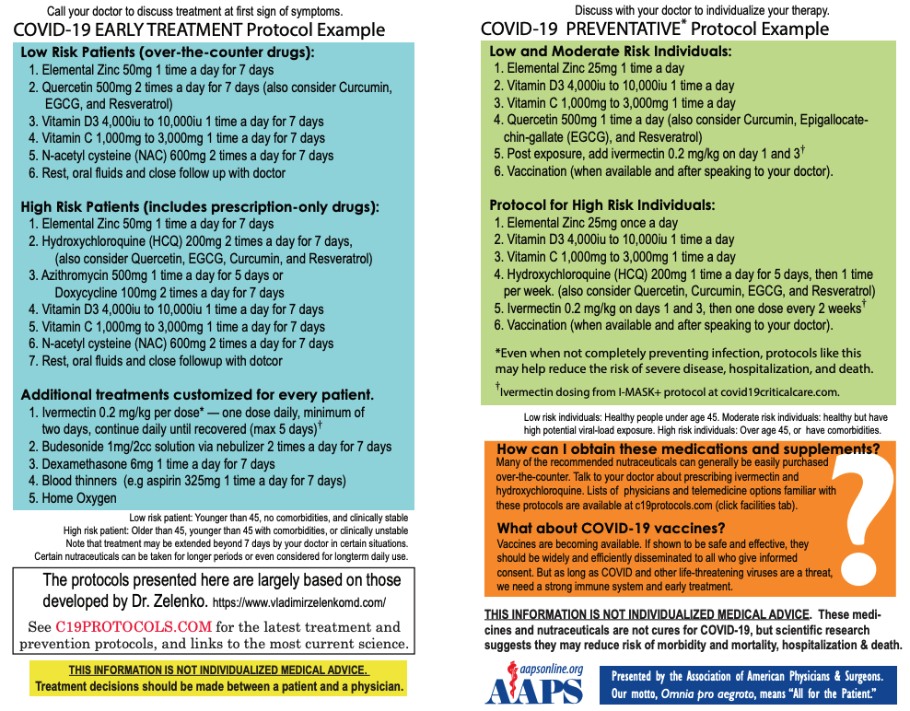
NOTE: On the vaccines they are saying IF shown to be safe and effective. Based on information in this paper that cannot be concluded based on either lack of long-term data or if you look at long-term data 78% the same, it was a terrible failure and not approved.
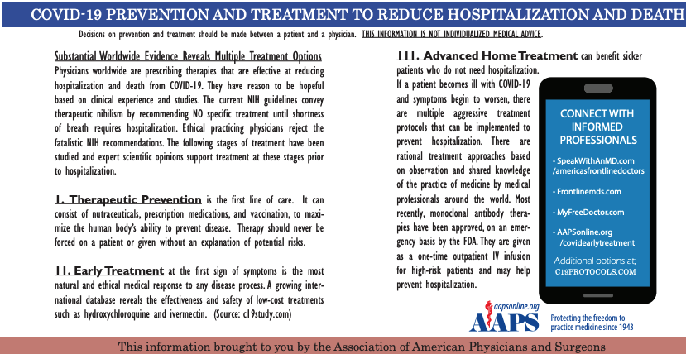
JOHNSON & JOHNSON EXPERIMENTAL VACCINE

Johnson and Johnson is summarized on the link below starting at 20:22 to 48:00.
The Johnson & Johnson vaccine does also have potential for antibody dependent enhancement which is the main concern with the other two vaccines available.

https://www.bitchute.com/video/fGrVfRKlrYtN/ View 20:22 to 48:00 time

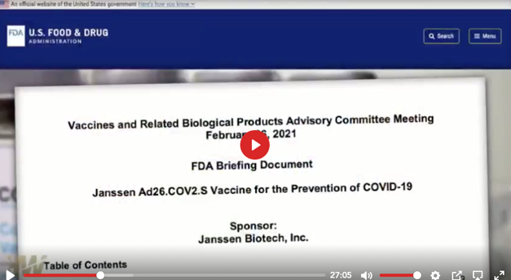
Johnson & Johnson 66% efficacy (43% efficacy for people over age 60).
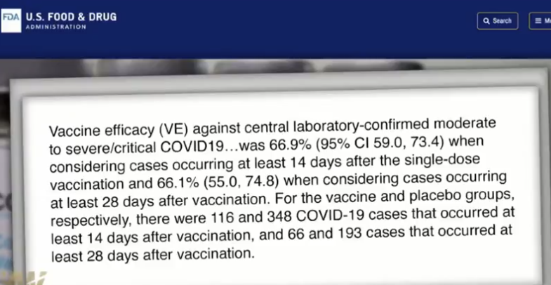
Table 13 shows that the efficacy for over 60 years of age where 81% of the deaths of COVID nationally have occurred is only 43%.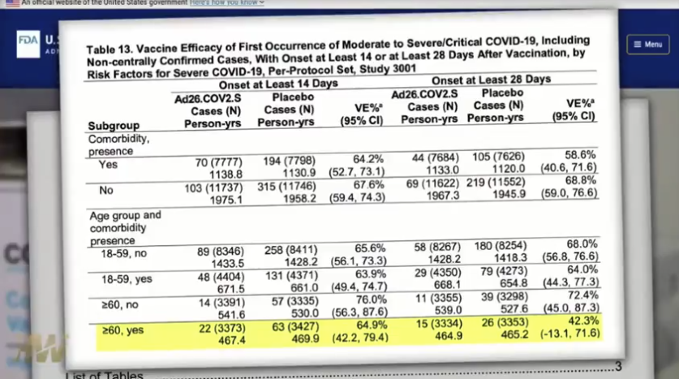
Aborted baby cells are included.
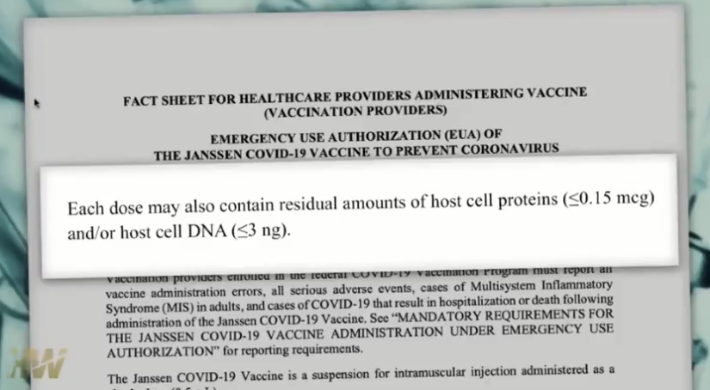

Johnson and Johnson has a history of paying damages. For the COVID experimental vaccine, they have immunity or no liability, so they don’t have to worry about that and the injured have no recourse.
See below amounts of 8M, 20.4 M, 572Million, $417 Million…paid in settlements.

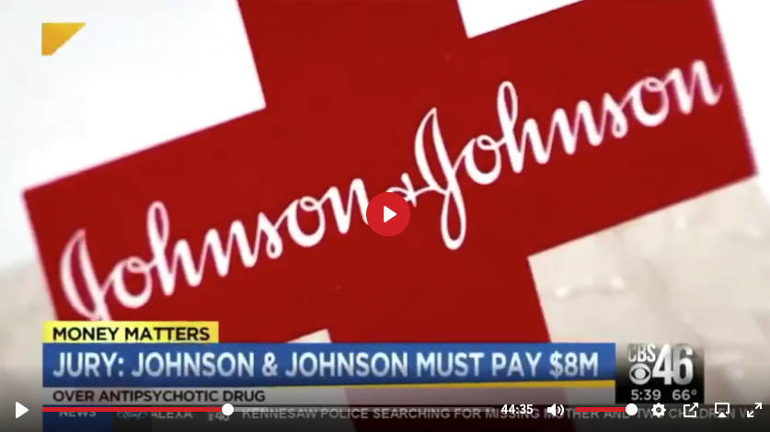

Settled on opioids before going to trial.

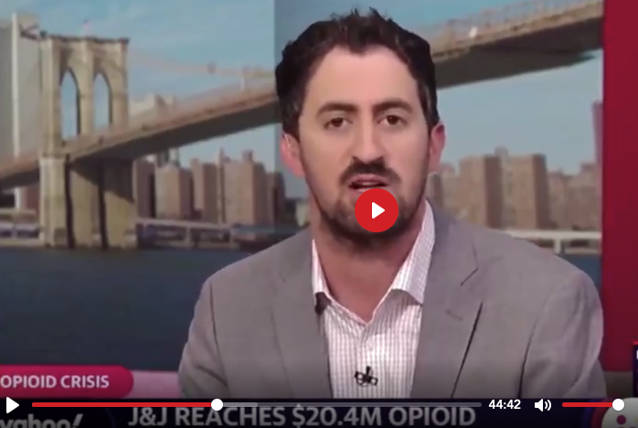



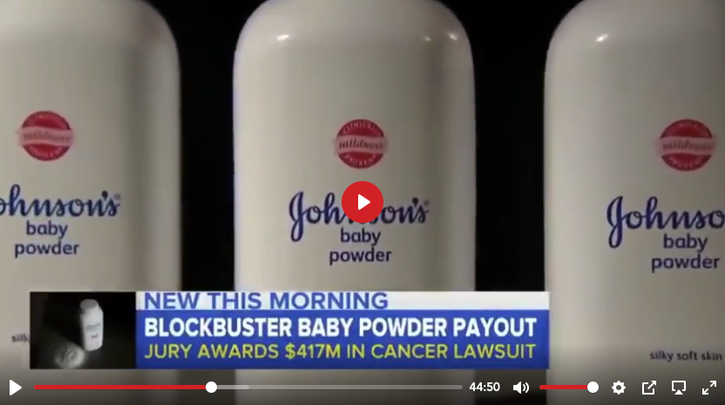

The newscaster said that in many of these cases the company, Johnson & Johnson, failed to warn people of the risks of the drug.

With the COVID-19 vaccine the companies were given immunity – no liability.

GENERAL REGULAR VACCINE INFORMATION

3-minute clip
Dr. Larry Palevsky at Public Health Committee Hearing

https://www.youtube.com/watch?v=ZaV7m2S4KXA

ADDITIONAL VIDEOS or INFORMATION:

These links can be copied and sent by text to others as desired.

Shot in the Dark: Joni and her whole family Daystar with Dr Sherri Tenpenny Good explanation what happens with cells. Dr is very blunt about situation.
https://youtu.be/8iaKAWWGyWI

Good summary Dr Hotze including how Moderna, now experimental “vaccine” was called gene therapy as they worked to get approved for cancer treatment for 10 years. Was not approved. Vaccines have immunity from liability as why to call it that.
https://www.hotzehwc.com/2021/02/dr-hotze-on-the-dangers-of-the-covid-19-vaccine/

Tucker on mandating vaccine - Your body, Your Choice in healthcare decisions
https://www.facebook.com/RandPaulRevolution2024/videos/786433235565106

Big Tech and others censorship of any negative including adverse reaction reports from Covid vaccine including taking down the Vaccine Injury Group top 20 at the time on Facebook-7min
https://www.foxnews.com/opinion/tucker-carlson-big-tech-silences-questions-about-covid-vaccine

No one allowed to question vaccines: This short link is within the 7 min one above so it can be skipped.
Covid vaccine:Why are Americans being discouraged from asking questions about it? Tons of celebrity endorsements not a lot of science (1:26 min)
https://www.independent.co.uk/news/world/americas/us-politics/tucker-carlson-covid-vaccines-fox-b1800310.html

Tucker on overreach on vaccine
https://www.facebook.com/watch/?v=408659947099247

Tucker on Covid vaccine in December on promotion like for Diet Pepsi and push
https://video.foxnews.com/v/6217010509001#sp=show-clips

Fauci and interviewer where Fauci obviously flips more than once. First about Pfizer, Moderna, that are given immunity or no liability. He says you can sue anyone you want and is not truthful that the companies have no liability. Secondly, on transmission he says 85% (or basically everyone) need to get the shot for herd immunity (which would mean to stop transmission of the virus). Then, in the next question, he says no the vaccine is not known that it will stop transmission (which is true) and masks will need to be worn.

Interviewer Instagram (Second link has full first link included, but adds commentary)
https://www.instagram.com/p/CMQOqwxDNy0/ Full interview within link below but adds commentary https://www.facebook.com/VaXismVideos/videos/264315011926274
You may want to only watch the second link with data showing the discrepancies.

Reaction to Fauci saying still mask wearing and no indoor dining or travel still after vaccine
https://www.bitchute.com/video/u4J9vhv7Dhtv/

Dr Scott Jensen 3 min on how they are saying vaccine to not transmission but not those who already have had covid
https://www.facebook.com/DrScottJensen/videos/1321692288223989

https://www.facebook.com/votewichmann/videos/826560861602263
World Renown Vaccine Creator/Expert risking his own reputation on his Linkedin appeals to all professionals in the world essentially stating we must stop the vaccination program immediately.
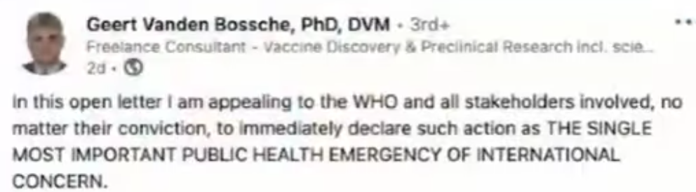
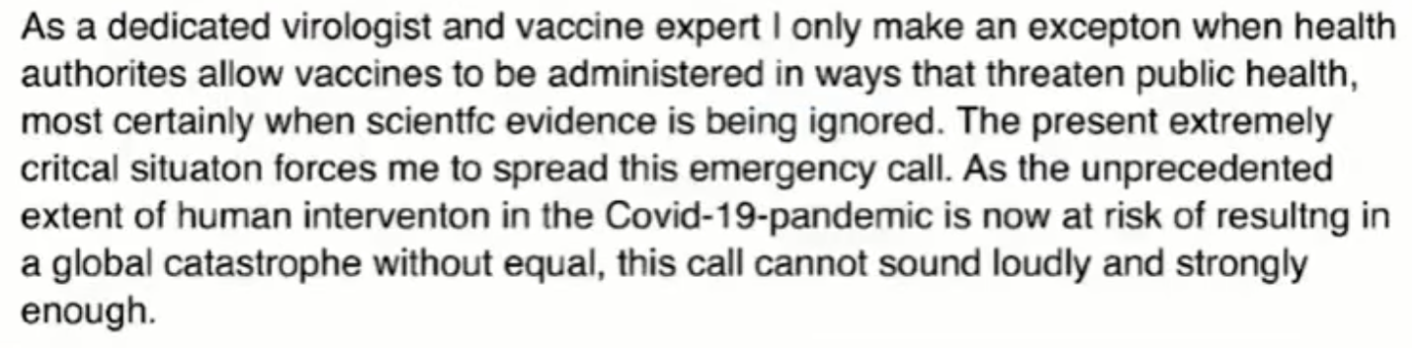

Secretary of State Pompeo: ‘Significant Evidence” coronavirus originated in Wuhan lab
https://www.foxnews.com/politics/mike-pompeo-evidence-coronavirus-originated-china-lab

Dr. Merritt on vaccine and biowarfare considered https://vimeo.com/506527035
Comparison of no lockdown in FL to lockdown states CA and NY

https://www.bitchute.com/video/MfxE2QVkSjB3/

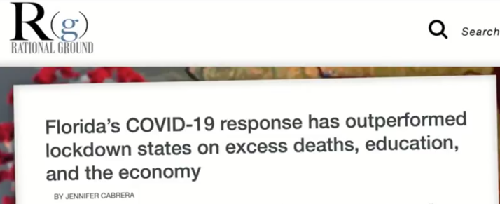
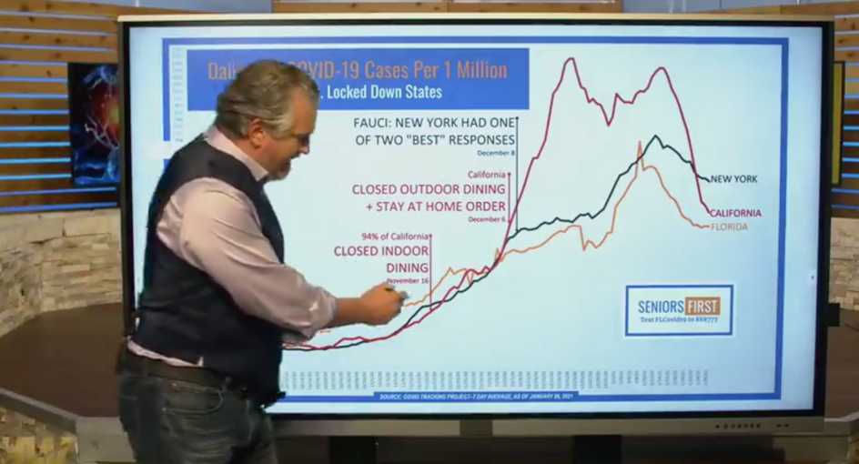

Masks:

Amount of Carbon Dioxide levels you breathe and effect (4 min)
https://www.bitchute.com/video/ypLjmXQoLygi/

Cancer Concern for Mask wearers

https://www.bitchute.com/video/x3xhsPAVGrM8/

March 19, 2021: Link below: Fauci vs Rand Paul on Masks and studies show immunity to COVID once had you have had COVID. (no need for vaccine) They talk about the vaccine here but remember the high risk of taking it long term – the antibodies keep building – there is no off switch and later on animals in the study (and humans in the case of denque fever) had a more severe case of coronavirus then if they had not been vaccinated. (yet at first things looked good.)
https://www.facebook.com/IngrahamRadio/videos/4080583201991668
Fed up People promoting Vaccine but Fauci says still need masks (beginning of video only)
https://www.bitchute.com/video/u4J9vhv7Dhtv/

Also, not mentioned previously from the Pfizer and Moderna Trials:
In Pfizer trials 3410 cases of suspected COVID but did not give PCR test.
Vaccine does not stop transmission.
